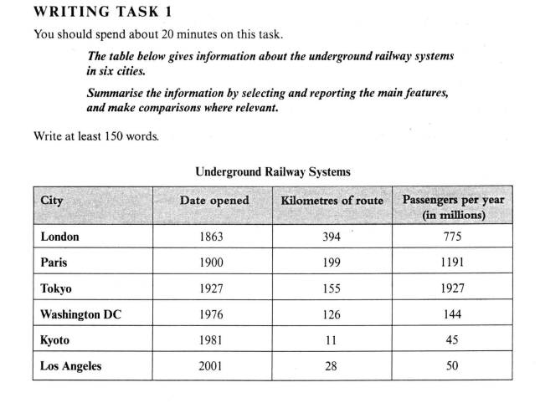

Subways in Different Countries

The table illustrates information of subways in multiple metropolitans around the world. It help us to understand the metro systems by offers three categories which are the date, the length, and the travelers.

To begin with, when it comes the date, London is the first city building its underground transportation system dating back to 1860s. After about forty years, the second one had been built in Paris. Surprisingly, Japan built its first metro in Tokyo in 1927 and then it constructed the second in Kyoto. However, as a developed country US built its first subway in 1970s and L.A. had not any subway until the first year of 21th centuries.

Secondly, the longest metro railway, which is about 400 km and is almost doubled to the second one in Paris, is in London. Whereas, Tokyo has the largest number of passengers and the smallest numbers of travelers is in another Japan’s city-Kyoto where there are also the shortest lane.

To summarise, metro is originated from Birtish and the longest one is also there. While as a densely populated Asian city, Tokyo has the ennomous numbers of people on the subway.